1. 

Association

1. Association relationship differs from Dependency Relationship in that a class doesn’t simply make use of another class (as in case of dependencies) - instead one class is explicitly coupled to another class because those classes communicate with each other.
2. Aggregation and composition relationships are specialized forms of association relationships.
3. 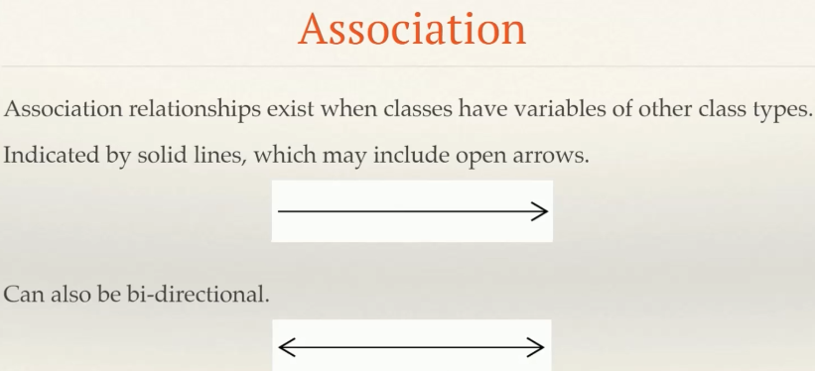
4. 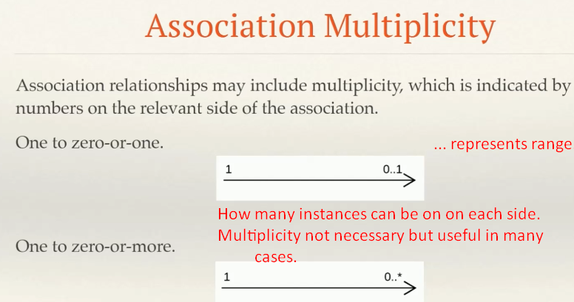
5. Lastly we can indicate the role names on associations.
6. 
7. 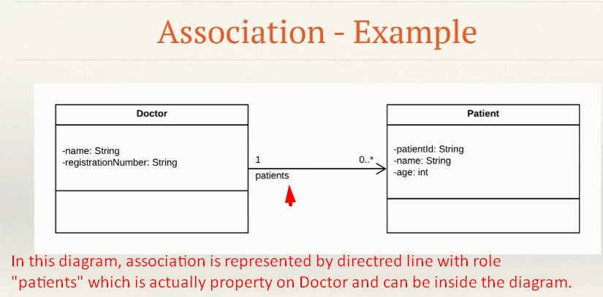  
   See Doctor has property patients, it doesn’t mean that Doctor consists of Patients. So this is not aggregation or composition but just association.
8. 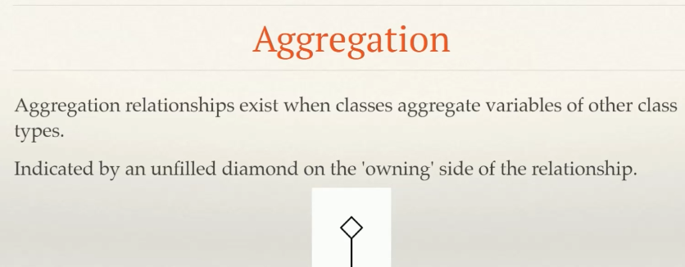
9. 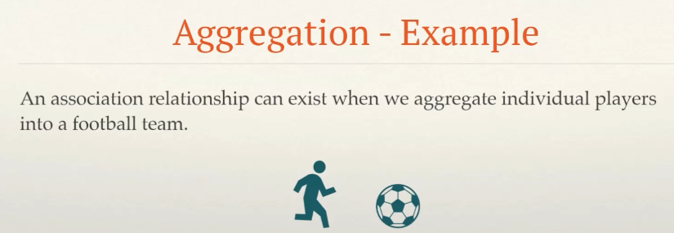
10. 